**IMPROVED AIR QUALITY MONITORING SYSTEM IN THE POST-HARVEST FACILITIES**

Table of Contents:

ACRONYMS AND ABBREVIATIONS 1

CHAPTER ONE 3

Introduction: 3

Background: 3

Problem Statement: 4

Main Objective: 4

Specific Objectives: 4

Justification: 4

CHAPTER TWO 5

Literature Review: 5

Cooling the grain bulk for pest suppression: 5

Suppression of microflora: 5

Maintenance of Seed and Grain Quality: 6

Equalization of temperature through-out the grain bulk: 6

CHAPTER THREE 7

Methodology: 7

The Hardware: 7

The Block Diagram: 8

Software: 8

REFERENCES 9

APPENDIX 10

Activity Plan: 10

Project Budget: 10

# ACRONYMS AND ABBREVIATIONS

MAAIF - Ministry of Agriculture Animal Industry and Fisheries

UART - Universal Asynchronous Receiver Transmitter

NAADS - National Agriculture Advisory Services

PWM - Pulse Width Modulation

USB - Universal Serial Bus

# CHAPTER ONE

## Introduction:

Agriculture is the major source of income in Uganda, enjoying the largest share of employment at 36% of the employment sector, contributing about 25% of the GDP in the Financial Year 2016/17 (MAAIF, 2024). Despite the numbers it has come to stack over the years and potential projections, post-harvest losses diminish it’s potential and farmer’s incomes (Post-harvest loss means a measurable qualitative or quantitative loss in a product). In a study that was conducted to asses the physical and economic post-harvest losses of coffee in Bushenyi district, it was discovered that 67% of coffee farmers in Bushenyi lost from 1-5kg of coffee that is Ugshs 5000 – 80000 (Tukamuhebwa, Medard, 2019). Daily Monitor ePaper also wrote about a research that showed that farmers lost Shs 16b every year in poor post-harvest handling (Monitor, 2021). Some practices like early harvest time, bad storage methods are easily counteracted but, in a situation, where farmers have checked these boxes, his prayer must redeem the storage. Aeration of the facility can make or break a farmer making grains chilly and susceptible to pests and mold or dry; losing weight and affecting sales. What this paper proposes is a solution that will keep watch of the aeration, detailing all characteristics and counteracting any abnormalies on the two extremes; chilly and dry; keeping the integrity of the harvest without the farmer’s intervention, let alone his prayer.

## Background:

Post-harvest facilities in their role of storing agricultural produce can be a home for pests, mold, weight loss and chemical contamination if harvest environment is not dictated. An acceptable practice to reduce quality loss is to use mechanical aeration by fans. It can easily be used to granular commodities. Aeration can be defined as the forced movement of air of suitable quality through harvest bulk for improved harvest storage. Aeration is also called “forced” ventilation because fans are used which distinguishes it from passive aeration like open windows or doors.

As a widely used method for the preservation of harvest. It modifies the harvest’s microclimate, rendering it unfavorable for the development of damaging organisms while creating favorable conditions for preservation of harvest’s quality. Aeration modifies temperature, humidity and atmospheric composition to it’s will giving the harvests a great bulk of moving desired quality air through all its mass.

## Problem Statement:

Post-harvest storage facilities lack controlled aeration mechanisms. Traditional aeration systems like open manhole grain bins, opening windows and doors and corn cribs lack the aspect of control which sets the risk of either getting the harvests too chilly or too dry with both having its own detrimental effects that amount into harvest quality loss. This paper proposes an air quality monitoring system that will control everything from the characteristics of the air to the amount that flows through the harvest’s bulk to preserve the quality.

## Main Objective:

To design, test and implement a system that will improve storage harvest quality within a storage facility through aeration.

## Specific Objectives:

1. To evaluate hardware (the microcontroller and sensors) to use for this system
2. To calibrate sensors, integrate sensor data with the microcontroller for decision making through software.
3. To merge everything into a working prototype of the system.

## Justification:

This study will help asses;

1. The cost feasibility of coming up with such a system.
2. The practicability of that system, is it possible? Can it be done?
3. The possibility of technology intervening in agriculture like can farmers adopt this?
4. The level of training required to operate such a system.

# CHAPTER TWO

## Literature Review:

Food losses and wastages arise mainly due to poor post-handling practices and through absence of appropriate food infrastructure and post-harvest systems. For example, during the preparation stages (poor drying leading to high moisture content) storage, transportation and processing. This paper will state how embracing technology will affect the quality and quantity of the harvest.

Majority of farmers still use rudimentary methods like drying on uncovered ground, storage in sacks or pouring on ground. Drying and storing on ground makes agricultural produce become susceptible to discoloration, and contamination with foreign matters, termite damage, mould and debris. Storage in inappropriate materials (non-hermetic bags) like bags or sacks makes the stored produce vulnerable to storage pests (like rodents, weevils, termites), contamination by mould and insects (Medard, Tiffany, 2022). This is why government is working hard to get public warehouses constructed and so far, 11 have been built through NAADs but these still don’t have no aeration mechanism in place though it is a significant step to solving the storage problem and farmers have started to learn about smart silos as they were a center of attention in the Harvest Money expo (Prossy N, 2024) that have aeration capabilities.

Manipulation of the harvest microclimate by use of aeration has long been recognized elsewhere and was first brought into focus in the early 1950’s in grain management programs in the United States with pioneering works of researchers like Shedd (1953) and more recently by Arthur and Casada (2005, 2010) which form the basis of modern grain aeration systems. They came up with one objective while developing their research “to maintain the quality of bulk grain in storage.” Their tests were extensive and these to the tropics and these are the findings;

## Cooling the grain bulk for pest suppression:

Insects from the tropics need a relatively high temperatures range typically between 24°C to 32°C, so, at temperatures below 21°C, most insect growth is suppressed. Therefore, temperatures between 16°C and 21°C are considered “safe” for insect management.

## Suppression of microflora:

Temperature below 5°C are needed for suppression of molds but, these molds need 70% or above humidity in the air to grow. Therefore, at lower grain temperatures, mold damage is reduced.

## Maintenance of Seed and Grain Quality:

Lower temperatures are required to maintain seed and grain quality because in such temperatures, the seeds maintain full viability! As a rule of thumb, a seed’s lifespan in storage is doubled for each 5°C in temperature between 0 to 50°C.

## Equalization of temperature through-out the grain bulk:

Grains keep “harvest heat” and this is recommended to be removed by night with suction aeration as soon as ambient temperatures are 8° to 11°C to prevent condensation and minimize insect activity. Initial cooling should be followed by additional aeration to cool the mass below 21°C.

In conclusion, research papers and articles have shown that famers still use rudimental methods of storage in the midst of climatic changes and a clear relationship has been drawn between drawn between these methods of storage and post-harvest losses and following solutions other countries have developed over decades can save the farmer some money and contribute to the general growth of the sector.

# CHAPTER THREE

## Methodology:

This section describes how the system will be realized (which will check the main objective of the project). The system will monitor temperature, humidity and a gas sensor whose values it shall transfer to the micro controller which will have predetermined conditions programmed into. The microcontroller will then check these values received against the optimal values and decide a course of action through actuation by buzzing, turning off or on one of the two fans; the inlet or outlet fans.

The microcontroller should meet the computing requirements of the system and have enough general-purpose input output pins to have all actuators and sensors connected to it. The sensors must have good response times and must be calibrated accurately before put to use.

## The Hardware:

**The MH-Z19 gas sensor module:**

The MH-Z19 gas sensor module detects the presence of carbon dioxide in the air. It has in-built temperature compensation capability that makes it resist interference caused by; water vapor and high sensitivity that make it an ideal solution to measure carbon dioxide levels. It communicated through UART and operates at 3.3V. A high carbon dioxide value in the setting correlates to presence of microorganisms like insects and molds with in the grains.

**DHT22 Humidity and Temperature Sensor module:**

This uses capacitive technology to capture the ambient temperature and relative humidity. It uses low power, it is portable and of a low cost which makes it suitable for this project. The DHT sensor module uses one wire communication protocol to send and receive data from a microcontroller.

**Arduino Uno R3**

The Arduino is a microcontroller breakout board based on the ATmega328p. It has 14 digital input output pins of which 6 can be used as PMW outputs via multiplexing, 6 analog inputs, a 16MHz ceramic resonator, a USB connection, a power jack, and a reset button. It contains everything needed to support to communicate to peripherals (sensors and actuators) like UART ports among others.

And last on the hardware will be the fans that will let in or out air according to the conditions at the time. These fans will be switched by the microcontroller.

## The Block Diagram:

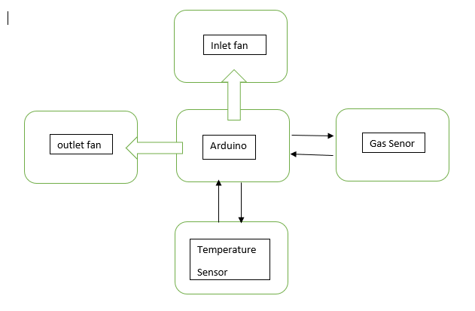

## Software:

A computer running windows operating system (XP, 7, 8, 10, 11) with Arduino IDE or Atmel Studio installed will be used.

# REFERENCES

Ministry of Agriculture, Animal Industry and Fisheries (2024). Agricultural Sector Potential in Uganda. Retrieved October 31, 2024, from <https://www.agriculture.go.ug/agricultural-sector-potential/>

Tukamuhebwa, Medard (2019, October). Assessing the post-harvest losses of coffee in Bushenyi District. Makerere University Undergraduate Dissertations Repository. Retrieved October 31, 2024, from <https://dissertations.mak.ac.ug/handle/20.500.12281/7446#:~:text=The%20study%20revealed%20thatmore%20than,to%20Ugshs%208000%2D60%2C000%20loss>.

Daily Monitor (2021, January 6). *Research shows farmers lose Shs16b every year in poor post-harvest handling*. Monitor ePaper. Retrieved October 31, 2024, from <https://www.monitor.co.ug/uganda/magazines/farming/research-shows-farmers-lose-shs16b-every-year-in-poor-post-harvest-handling-1588380>

Medard, Tiffany (2022, August). Uganda’s food loss and waste dilemma: The role of post-harvest handling. Economic Policy Research Center. Retrieved November 1, 2024 from <https://eprcug.org/press-releases/ugandas-food-loss-and-waste-dilemma-the-role-of-post-harvest-handling/#:~:text=There%20are%20only%20eight%20warehouses,no%20access%20to%20storage%20facilities>.

<https://naads.or.ug/grain-storage-facilities-2/>

Prossy Nandudu (Feb, 2024). Earn premium prices from grains through smart silos. New Vision. Retrieved November 1, 2024 from <https://www.newvision.co.ug/category/agriculture/earn-premium-prices-from-grains-through-smart-NV_182026>

Arthur, F. H., Casada, M. E. 2005. Feasibility of summer aeration for management of wheat stored in Kansas. Appl. Eng. Agric. 21: 1027-1038.Arthur, F. H., Casada, M. E. 2010. Directional flow of summer aeration to manage insect pests in stored wheat.

Shedd, C.K. 1953. Resistance of grain and seeds to airflow. Trans. ASAE. 34: 616-619.

# APPENDIX

## Activity Plan:

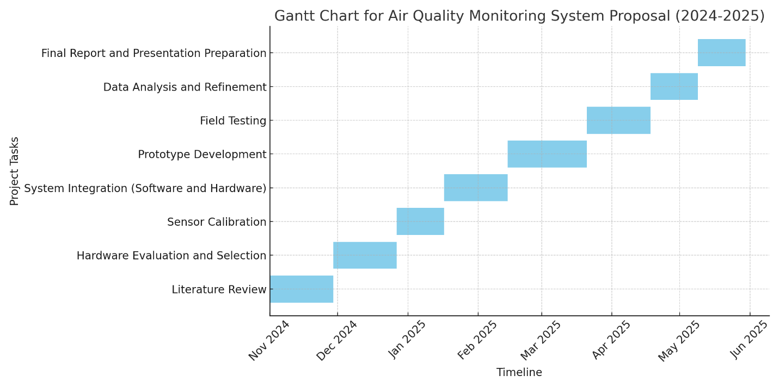

## Project Budget:

|  |  |
| --- | --- |
| **ITEM** | **PRICE (Shs)** |
| ARDUINO | 55000 |
| TEMPERATURE SENSOR | 25000 |
| HUMIDITY SENSOR | 25000 |
| FANS (2) | 60000 |
| **TOTAL** | 135000 |